BCSE417P Fall 2024-25 Lab Assignments-3

Laleeth Adithya S 21BAl1 8 6 3

November 13, 2024

By turning in this assignment, I agree and declare that all of this is my own work.

**Task 1: Motion Estimation and Event Detection in a Video**

**Objective**:  
Detect motion and specific events in a video using frame differencing or optical flow to estimate motion and identify events without machine learning.

**Task Description**:

1. **Load Video**:
   * Load the provided video using OpenCV.
2. **Motion Estimation**:
   * Use **frame differencing** (Histogram comparision) to detect changes between consecutive frames.
     + Subtract consecutive frames and threshold the difference to identify regions of motion.
3. **Event Detection**:
   * Detect significant motion events, such as sudden movements or object appearances, based on the intensity of motion detected in specific regions.
   * Identify and mark frames where events occur based on changes in motion intensity or region activity.
4. **Result**:
   * Visualize motion by highlighting moving regions in each frame.
   * Display and annotate the frames where events were detected, along with timestamps.

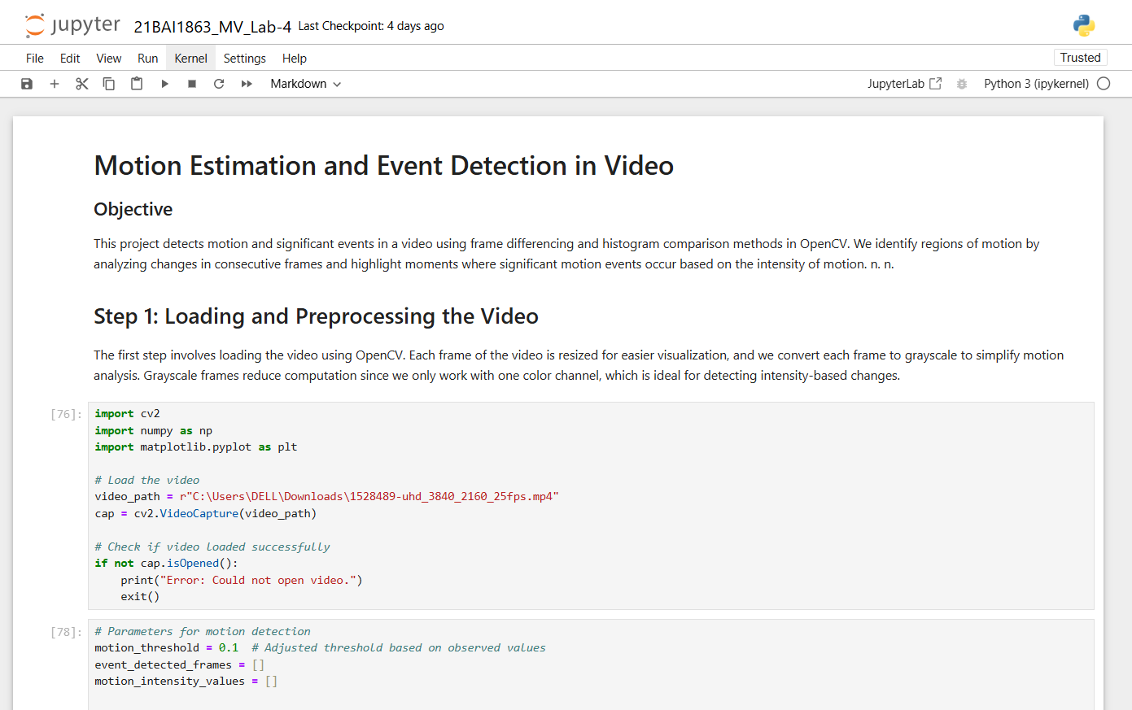

**Input Video Link:**

<https://drive.google.com/file/d/1z5pBj7dPkYCG3QWGffynevXdqa2lByNz/view?usp=sharing>

**Motion Detection Link:**

<https://drive.google.com/file/d/1JlHxhaSXX1SnUE9nYY9aERGL0CL6G-qE/view?usp=sharing>

**Github Link:**